**LAB 5: INTRODUCTION TO CLASSES (UML DIAGRAMS)**

The below UML are made using https://creately.com/.

**Program 5.1**

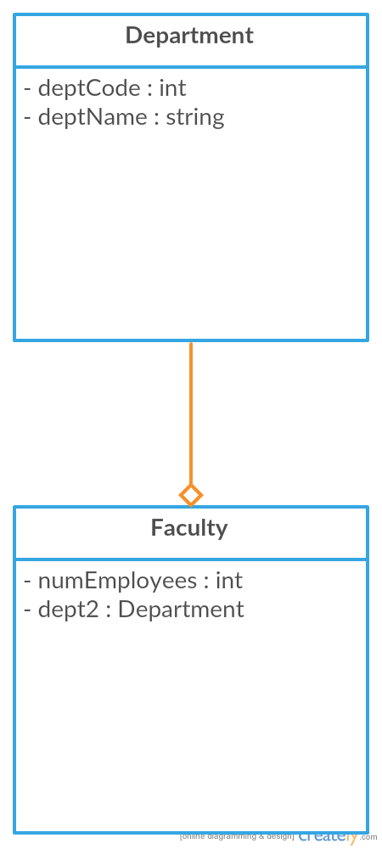

**Program 5.2**

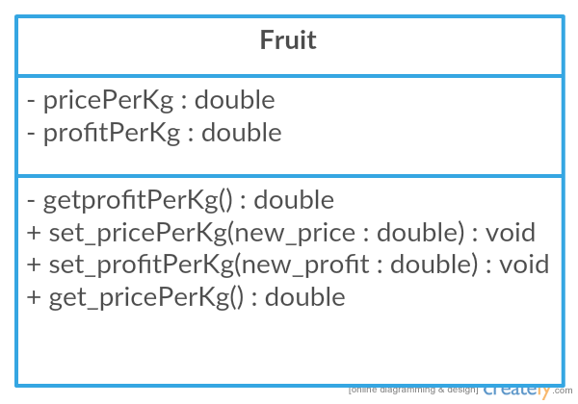

**Program 5.3**

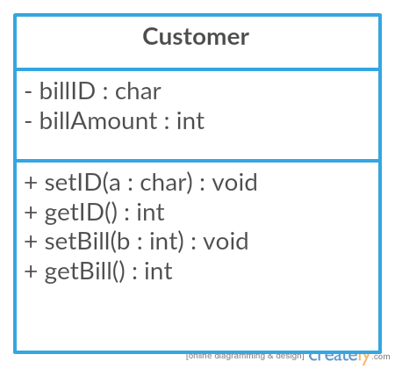

**Program 5.4**

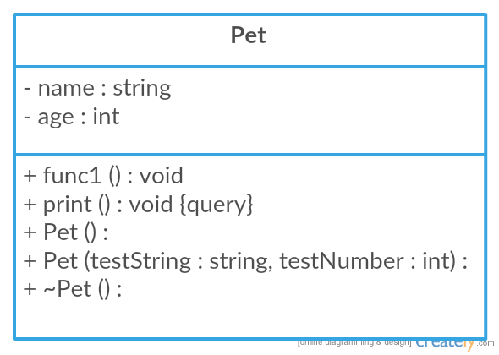

**Program 5.5**

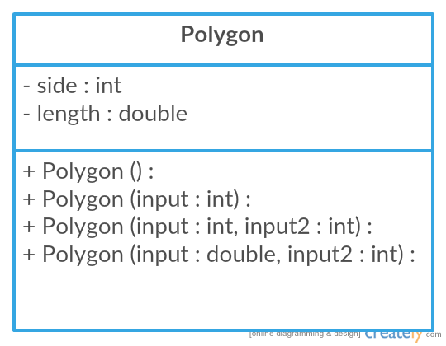

**Program 5.6**

Code/ answers refer to answers/ code of Lab 5 in front

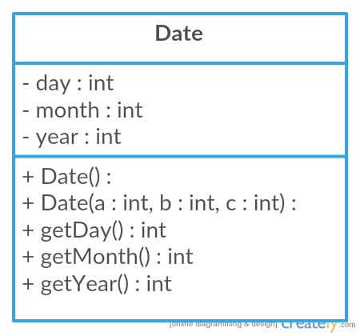

**Program 5.7, 5.8, 5.9**

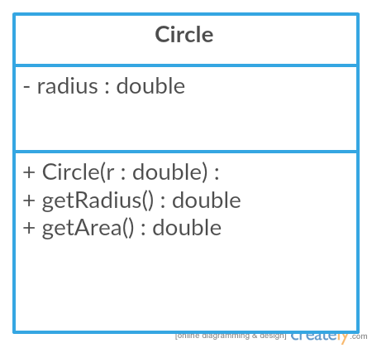

**Program 5.10**

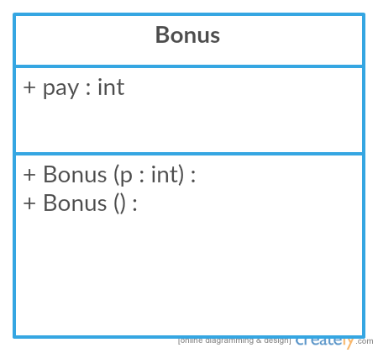

**Program 5.11**

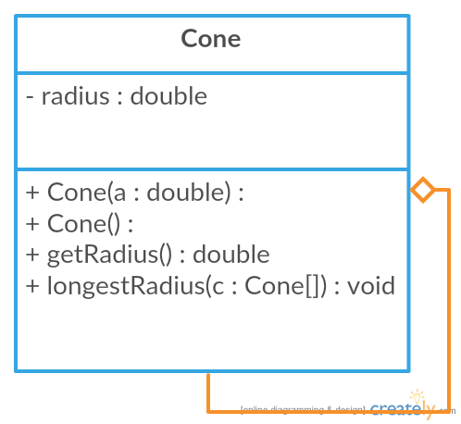

**Program 5.12**

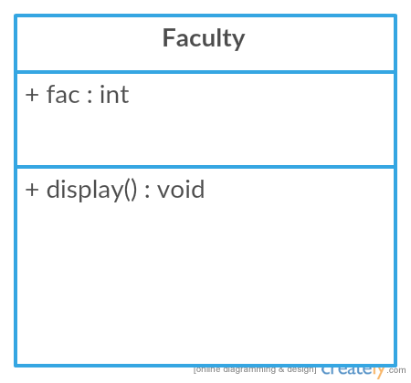

**Program 5.13**

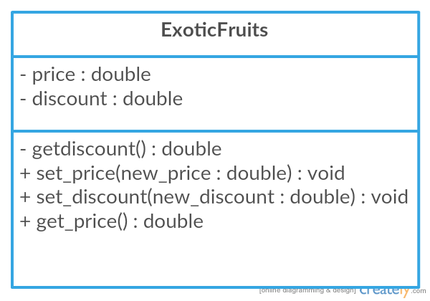

**Program 5.14, 5.15, 5.16**

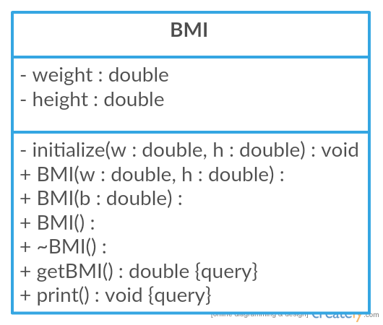

**Program 5.17**

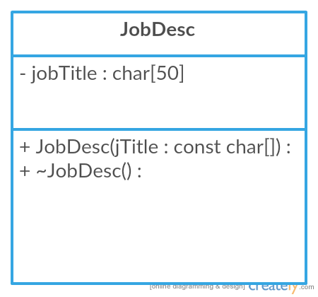

**Program 5.18**

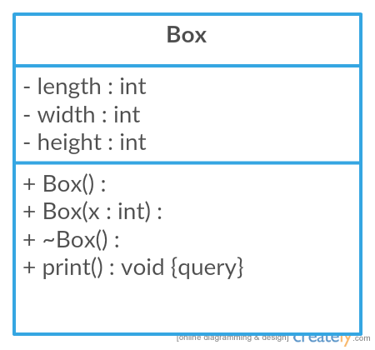

**Program 5.19, 5.20, 5.21**

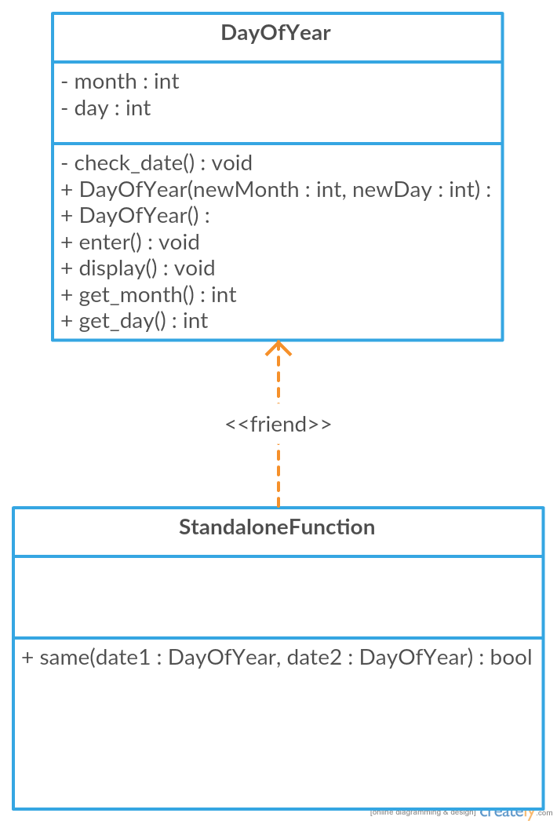

**Program 5.22, 5.23**

